NAME: Abdikaafi xasan Ahmed ID:C240327

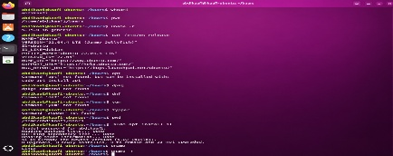

Commands | Options | Description
whoami | None | Displays system or session information by running whoami.  The output helps you inspect the current user, operating system, processor, memory, or storage.  This command is mainly used to check information and does not normally change system settings.
pwd | None | Displays system or session information by running pwd.  The output helps you inspect the current user, operating system, processor, memory, or storage.  This command is mainly used to check information and does not normally change system settings.
uname -r | -r | Displays system or session information by running uname -r.  The output helps you inspect the current user, operating system, processor, memory, or storage.  This command is mainly used to check information and does not normally change system settings.
cat /etc/os-release | /etc/os-release | Displays file contents or information about a file.  Options can limit output, follow new log entries, or show additional file details.  These commands are useful when reading text files, configuration files, and system logs.
apt | None | Manages software packages on Linux distributions that support this package tool.  The command and its options determine whether packages are installed, removed, queried, or updated.  Package changes may affect the whole system and can require administrator permission.
dpkg | None | Manages software packages on Linux distributions that support this package tool.  The command and its options determine whether packages are installed, removed, queried, or updated.  Package changes may affect the whole system and can require administrator permission.
dnf | None | Manages software packages on Linux distributions that support this package tool.  The command and its options determine whether packages are installed, removed, queried, or updated.  Package changes may affect the whole system and can require administrator permission.
yum | None | Manages software packages on Linux distributions that support this package tool.  The command and its options determine whether packages are installed, removed, queried, or updated.  Package changes may affect the whole system and can require administrator permission.
zypper | None | Manages software packages on Linux distributions that support this package tool.  The command and its options determine whether packages are installed, removed, queried, or updated.  Package changes may affect the whole system and can require administrator permission.
pwd | None | Displays system or session information by running pwd.  The output helps you inspect the current user, operating system, processor, memory, or storage.  This command is mainly used to check information and does not normally change system settings.
sudo apt install sl | apt install sl | Runs the command that follows with administrator privileges when permitted.  The command after sudo determines the action and may change system-wide settings.  Read the full command carefully and use elevated access only when it is necessary.
uname | None | Displays system or session information by running uname.  The output helps you inspect the current user, operating system, processor, memory, or storage.  This command is mainly used to check information and does not normally change system settings.
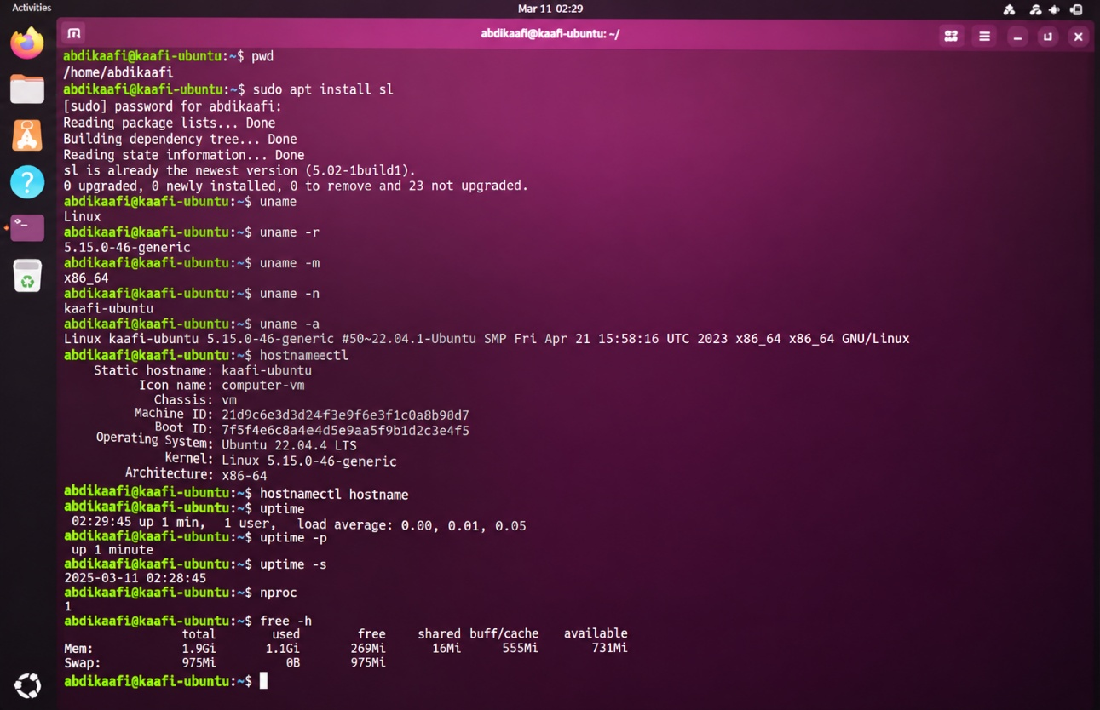
Pwd 1 | None | Displays system or session information by running pwd.  The output helps you inspect the current user, operating system, processor, memory, or storage.  This command is mainly used to check information and does not normally change system settings.
sudo apt install sl | apt install sl | Runs the command that follows with administrator privileges when permitted.  The command after sudo determines the action and may change system-wide settings.  Read the full command carefully and use elevated access only when it is necessary.
uname | None | Displays system or session information by running uname.  The output helps you inspect the current user, operating system, processor, memory, or storage.  This command is mainly used to check information and does not normally change system settings.
uname -r | -r | Displays system or session information by running uname -r.  The output helps you inspect the current user, operating system, processor, memory, or storage.  This command is mainly used to check information and does not normally change system settings.
uname -m | -m | Displays system or session information by running uname -m.  The output helps you inspect the current user, operating system, processor, memory, or storage.  This command is mainly used to check information and does not normally change system settings.
uname -n | -n | Displays system or session information by running uname -n.  The output helps you inspect the current user, operating system, processor, memory, or storage.  This command is mainly used to check information and does not normally change system settings.
uname -a | -a | Displays system or session information by running uname -a.  The output helps you inspect the current user, operating system, processor, memory, or storage.  This command is mainly used to check information and does not normally change system settings.
hostnamectl | None | Displays system or session information by running hostnamectl.  The output helps you inspect the current user, operating system, processor, memory, or storage.  This command is mainly used to check information and does not normally change system settings.
hostnamectl hostname | hostname | Displays system or session information by running hostnamectl hostname.  The output helps you inspect the current user, operating system, processor, memory, or storage.  This command is mainly used to check information and does not normally change system settings.
uptime | None | Displays system or session information by running uptime.  The output helps you inspect the current user, operating system, processor, memory, or storage.  This command is mainly used to check information and does not normally change system settings.
uptime -p | -p | Displays system or session information by running uptime -p.  The output helps you inspect the current user, operating system, processor, memory, or storage.  This command is mainly used to check information and does not normally change system settings.
uptime -s | -s | Displays system or session information by running uptime -s.  The output helps you inspect the current user, operating system, processor, memory, or storage.  This command is mainly used to check information and does not normally change system settings.
nproc | None | Displays system or session information by running nproc.  The output helps you inspect the current user, operating system, processor, memory, or storage.  This command is mainly used to check information and does not normally change system settings.
free -h | -h | Displays system or session information by running free -h.  The output helps you inspect the current user, operating system, processor, memory, or storage.  This command is mainly used to check information and does not normally change system settings.
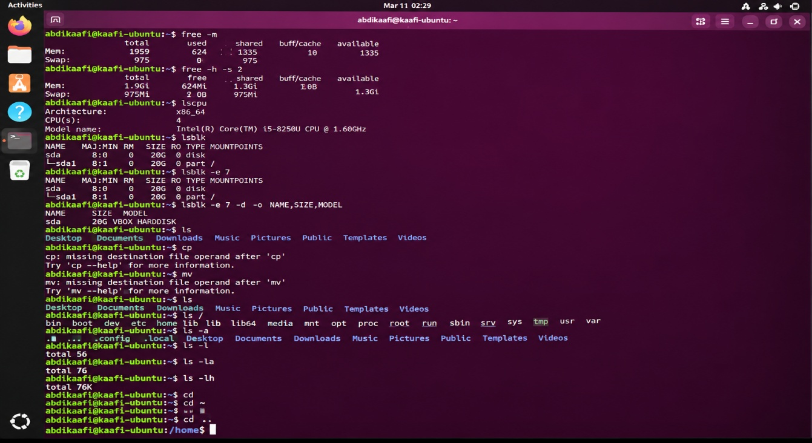

free -m 2 | -m | Displays system or session information by running free -m.  The output helps you inspect the current user, operating system, processor, memory, or storage.  This command is mainly used to check information and does not normally change system settings.
free -h -s 2 | -h -s 2 | Displays system or session information by running free -h -s 2.  The output helps you inspect the current user, operating system, processor, memory, or storage.  This command is mainly used to check information and does not normally change system settings.
lscpu | None | Displays system or session information by running lscpu.  The output helps you inspect the current user, operating system, processor, memory, or storage.  This command is mainly used to check information and does not normally change system settings.
lsblk | None | Displays system or session information by running lsblk.  The output helps you inspect the current user, operating system, processor, memory, or storage.  This command is mainly used to check information and does not normally change system settings.
lsblk -e 7 | -e 7 | Displays system or session information by running lsblk -e 7.  The output helps you inspect the current user, operating system, processor, memory, or storage.  This command is mainly used to check information and does not normally change system settings.
lsblk -e 7 -d -o NAME,SIZE,MODEL | -e 7 -d -o NAME,SIZE,MODEL | Displays system or session information by running lsblk -e 7 -d -o NAME,SIZE,MODEL.  The output helps you inspect the current user, operating system, processor, memory, or storage.  This command is mainly used to check information and does not normally change system settings.
ls | None | Lists files and directories in the selected location.  The path, filename, or option shown in the command determines what it acts on.  Check your location with pwd and verify the target before changing or deleting files.
cp | None | Copies a file or directory to another location.  The path, filename, or option shown in the command determines what it acts on.  Check your location with pwd and verify the target before changing or deleting files.
mv | None | Moves a file or directory, or changes its name.  The path, filename, or option shown in the command determines what it acts on.  Check your location with pwd and verify the target before changing or deleting files.
ls | None | Lists files and directories in the selected location.  The path, filename, or option shown in the command determines what it acts on.  Check your location with pwd and verify the target before changing or deleting files.
ls / | / | Lists files and directories in the selected location.  The path, filename, or option shown in the command determines what it acts on.  Check your location with pwd and verify the target before changing or deleting files.
ls -a | -a | Lists files and directories in the selected location.  The path, filename, or option shown in the command determines what it acts on.  Check your location with pwd and verify the target before changing or deleting files.
ls -l | -l | Lists files and directories in the selected location.  The path, filename, or option shown in the command determines what it acts on.  Check your location with pwd and verify the target before changing or deleting files.
ls -la | -la | Lists files and directories in the selected location.  The path, filename, or option shown in the command determines what it acts on.  Check your location with pwd and verify the target before changing or deleting files.
ls -lh | -lh | Lists files and directories in the selected location.  The path, filename, or option shown in the command determines what it acts on.  Check your location with pwd and verify the target before changing or deleting files.
cd | None | Changes the current working directory in the shell.  The path, filename, or option shown in the command determines what it acts on.  Check your location with pwd and verify the target before changing or deleting files.
cd ~ | ~ | Changes the current working directory in the shell.  The path, filename, or option shown in the command determines what it acts on.  Check your location with pwd and verify the target before changing or deleting files.
cd .. 2 | .. | Changes the current working directory in the shell.  The path, filename, or option shown in the command determines what it acts on.  Check your location with pwd and verify the target before changing or deleting files.
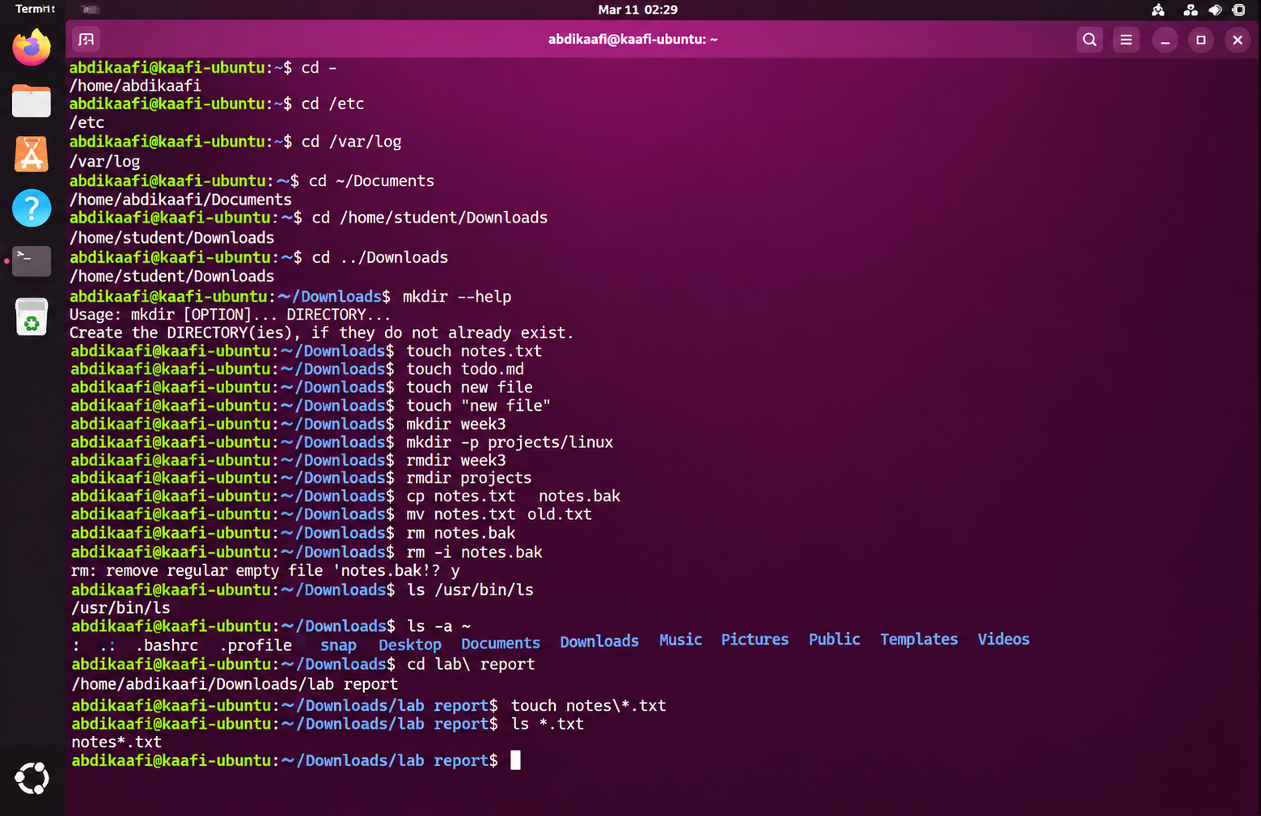

cd -3 | -
cd /etc | /etc
cd /var/log | /var/log
cd ~/Documents | ~/Documents
cd /home/student/Downloads | /home/student/Downloads
cd ../Downloads | ../Downloads
mkdir --help | --help
touch notes.txt | notes.txt
touch todo.md | todo.md
touch new file | new file
touch "new file" | "new file"
mkdir week3 | week3
mkdir -p projects/linux | -p projects/linux
rmdir week3 | week3
rmdir projects | projects
cp notes.txt notes.bak | notes.txt notes.bak
mv notes.txt old.txt | notes.txt old.txt
rm notes.bak | notes.bak
rm -i notes.bak | -i notes.bak
ls /usr/bin/ls | /usr/bin/ls
ls -a ~ | -a ~
cd lab\ report | lab\ report
touch notes\*.txt | notes\*.txt
ls *.txt | *.txt 3

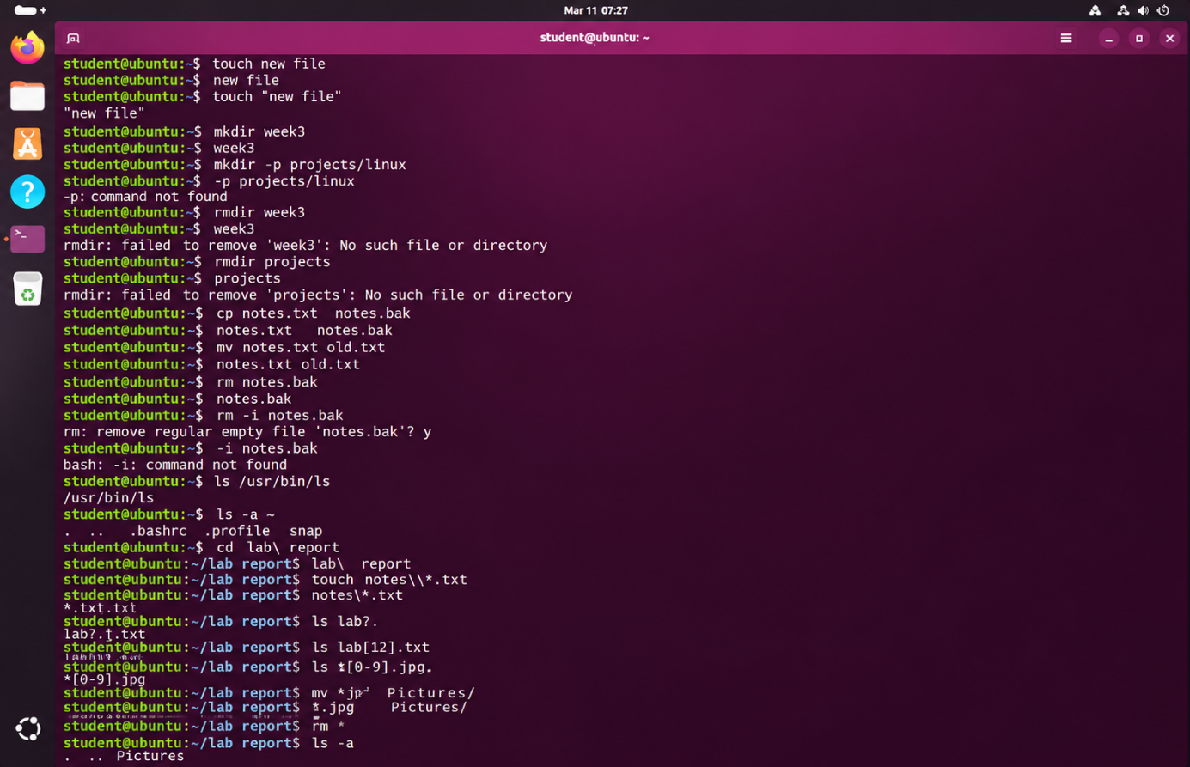

touch new file | new file 4 | Creates an empty file or updates an existing file's timestamps.  The path, filename, or option shown in the command determines what it acts on.  Check your location with pwd and verify the target before changing or deleting files.
touch "new file" | "new file" | Creates an empty file or updates an existing file's timestamps.  The path, filename, or option shown in the command determines what it acts on.  Check your location with pwd and verify the target before changing or deleting files.
mkdir week3 | week3 | Creates a new directory at the specified path.  The path, filename, or option shown in the command determines what it acts on.  Check your location with pwd and verify the target before changing or deleting files.
mkdir -p projects/linux | -p projects/linux | Creates a new directory at the specified path.  The path, filename, or option shown in the command determines what it acts on.  Check your location with pwd and verify the target before changing or deleting files.
rmdir week3 | week3 | Removes a directory only when it is empty.  The path, filename, or option shown in the command determines what it acts on.  Check your location with pwd and verify the target before changing or deleting files.
rmdir projects | projects | Removes a directory only when it is empty.  The path, filename, or option shown in the command determines what it acts on.  Check your location with pwd and verify the target before changing or deleting files.
cp notes.txt notes.bak | notes.txt notes.bak | Copies a file or directory to another location.  The path, filename, or option shown in the command determines what it acts on.  Check your location with pwd and verify the target before changing or deleting files.
mv notes.txt old.txt | notes.txt old.txt | Moves a file or directory, or changes its name.  The path, filename, or option shown in the command determines what it acts on.  Check your location with pwd and verify the target before changing or deleting files.
rm notes.bak | notes.bak | Removes files; deleted files may be difficult to recover.  The path, filename, or option shown in the command determines what it acts on.  Check your location with pwd and verify the target before changing or deleting files.
rm -i notes.bak | -i notes.bak | Removes files; deleted files may be difficult to recover.  The path, filename, or option shown in the command determines what it acts on.  Check your location with pwd and verify the target before changing or deleting files.
ls /usr/bin/ls | /usr/bin/ls | Lists files and directories in the selected location.  The path, filename, or option shown in the command determines what it acts on.  Check your location with pwd and verify the target before changing or deleting files.
ls -a ~ | -a ~ | Lists files and directories in the selected location.  The path, filename, or option shown in the command determines what it acts on.  Check your location with pwd and verify the target before changing or deleting files.
cd lab\ report | lab\ report 5 | Changes the current working directory in the shell.  The path, filename, or option shown in the command determines what it acts on.  Check your location with pwd and verify the target before changing or deleting files.
touch notes\*.txt | notes\*.txt | Creates an empty file or updates an existing file's timestamps.  The path, filename, or option shown in the command determines what it acts on.  Check your location with pwd and verify the target before changing or deleting files.
ls *.txt | *.txt 3 | Lists files and directories in the selected location.  The path, filename, or option shown in the command determines what it acts on.  Check your location with pwd and verify the target before changing or deleting files.
ls lab?.txt | lab?.txt | Lists files and directories in the selected location.  The path, filename, or option shown in the command determines what it acts on.  Check your location with pwd and verify the target before changing or deleting files.
ls lab[12].txt | lab[12].txt | Lists files and directories in the selected location.  The path, filename, or option shown in the command determines what it acts on.  Check your location with pwd and verify the target before changing or deleting files.
ls *[0-9].jpg | *[0-9].jpg | Lists files and directories in the selected location.  The path, filename, or option shown in the command determines what it acts on.  Check your location with pwd and verify the target before changing or deleting files.
mv *.jpg Pictures/ | *.jpg Pictures/ | Moves a file or directory, or changes its name.  The path, filename, or option shown in the command determines what it acts on.  Check your location with pwd and verify the target before changing or deleting files.
rm * | * | Removes files; deleted files may be difficult to recover.  The path, filename, or option shown in the command determines what it acts on.  Check your location with pwd and verify the target before changing or deleting files.
ls -a | -a | Lists files and directories in the selected location.  The path, filename, or option shown in the command determines what it acts on.  Check your location with pwd and verify the target before changing or deleting files.
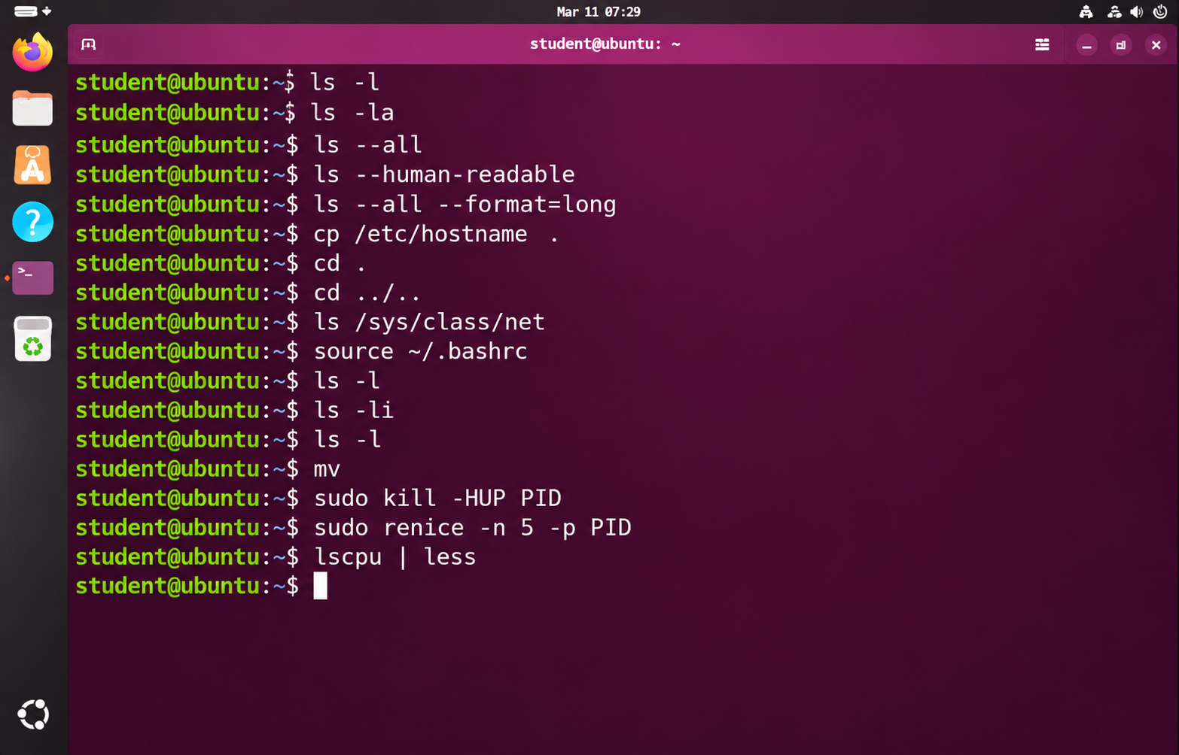

ls -l | -l | Lists files and directories in the selected location.  The path, filename, or option shown in the command determines what it acts on.  Check your location with pwd and verify the target before changing or deleting files.
ls -la | -la | Lists files and directories in the selected location.  The path, filename, or option shown in the command determines what it acts on.  Check your location with pwd and verify the target before changing or deleting files.
ls --all | --all | Lists files and directories in the selected location.  The path, filename, or option shown in the command determines what it acts on.  Check your location with pwd and verify the target before changing or deleting files.
ls --human-readable | --human-readable | Lists files and directories in the selected location.  The path, filename, or option shown in the command determines what it acts on.  Check your location with pwd and verify the target before changing or deleting files.
ls --all --format=long | Variable assignment | Lists files and directories in the selected location.  The path, filename, or option shown in the command determines what it acts on.  Check your location with pwd and verify the target before changing or deleting files.
cp /etc/hostname . | /etc/hostname . | Copies a file or directory to another location.  The path, filename, or option shown in the command determines what it acts on.  Check your location with pwd and verify the target before changing or deleting files.
cd . | . | Changes the current working directory in the shell.  The path, filename, or option shown in the command determines what it acts on.  Check your location with pwd and verify the target before changing or deleting files.
cd ../.. | ../.. | Changes the current working directory in the shell.  The path, filename, or option shown in the command determines what it acts on.  Check your location with pwd and verify the target before changing or deleting files.
ls /sys/class/net | /sys/class/net | Lists files and directories in the selected location.  The path, filename, or option shown in the command determines what it acts on.  Check your location with pwd and verify the target before changing or deleting files.
source ~/.bashrc | ~/.bashrc | Displays help, prints text, or checks shell commands and environment settings.  It can help you learn command syntax, inspect variables, or review commands entered earlier.  Most forms display information or affect only the current shell session.
ls -l | -l | Lists files and directories in the selected location.  The path, filename, or option shown in the command determines what it acts on.  Check your location with pwd and verify the target before changing or deleting files.
ls -li | -li | Lists files and directories in the selected location.  The path, filename, or option shown in the command determines what it acts on.  Check your location with pwd and verify the target before changing or deleting files.
ls -l | -l | Lists files and directories in the selected location.  The path, filename, or option shown in the command determines what it acts on.  Check your location with pwd and verify the target before changing or deleting files.
mv | None | Moves a file or directory, or changes its name.  The path, filename, or option shown in the command determines what it acts on.  Check your location with pwd and verify the target before changing or deleting files.
sudo kill -HUP PID | kill -HUP PID | Runs the command that follows with administrator privileges when permitted.  The command after sudo determines the action and may change system-wide settings.  Read the full command carefully and use elevated access only when it is necessary.
sudo renice -n 5 -p PID | renice -n 5 -p PID | Runs the command that follows with administrator privileges when permitted.  The command after sudo determines the action and may change system-wide settings.  Read the full command carefully and use elevated access only when it is necessary.
lscpu | less | | less 5 | Displays system or session information by running lscpu | less.  The output helps you inspect the current user, operating system, processor, memory, or storage.  This command is mainly used to check information and does not normally change system settings.

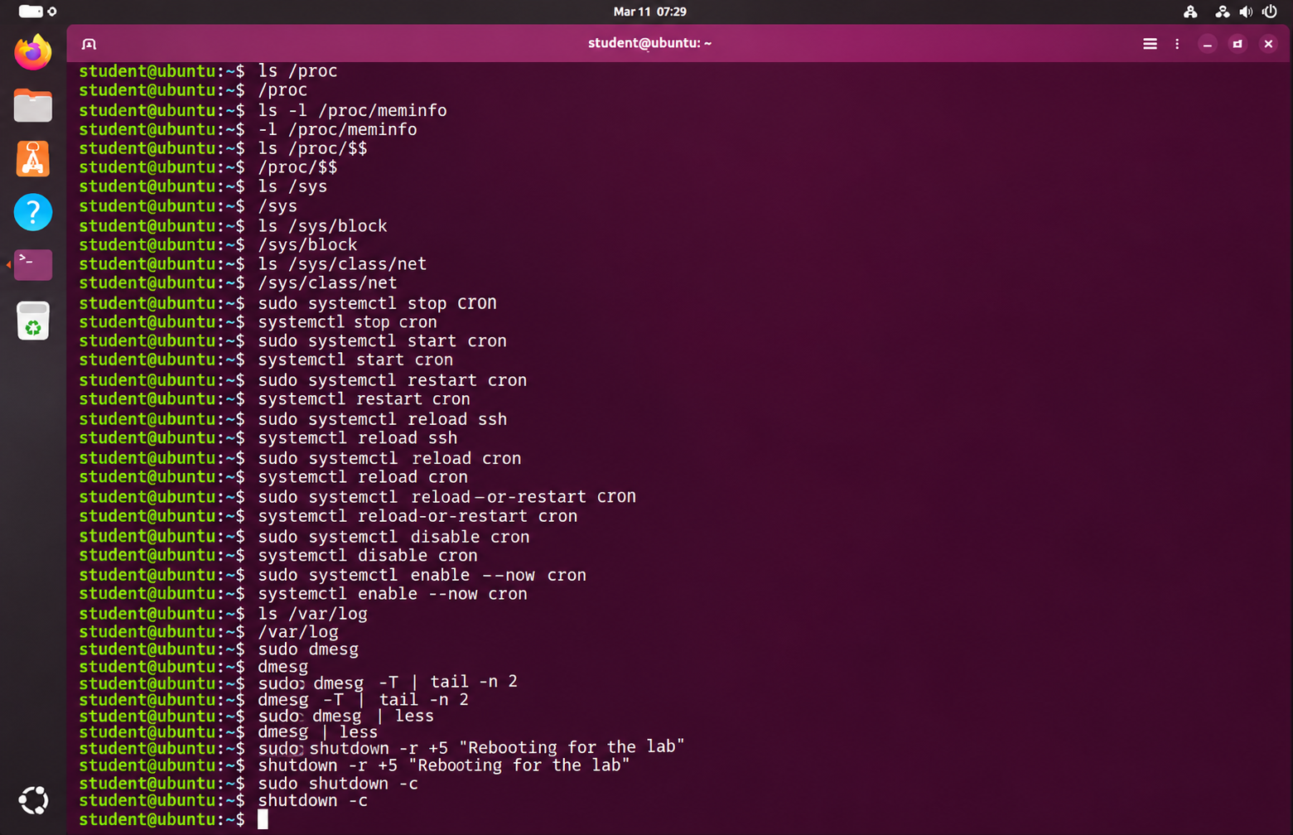

ls /proc | /proc | Lists files and directories in the selected location.  The path, filename, or option shown in the command determines what it acts on.  Check your location with pwd and verify the target before changing or deleting files.
ls -l /proc/meminfo | -l /proc/meminfo | Lists files and directories in the selected location.  The path, filename, or option shown in the command determines what it acts on.  Check your location with pwd and verify the target before changing or deleting files.
ls /proc/$$ | /proc/$$ | Lists files and directories in the selected location.  The path, filename, or option shown in the command determines what it acts on.  Check your location with pwd and verify the target before changing or deleting files.
ls /sys | /sys | Lists files and directories in the selected location.  The path, filename, or option shown in the command determines what it acts on.  Check your location with pwd and verify the target before changing or deleting files.
ls /sys/block | /sys/block | Lists files and directories in the selected location.  The path, filename, or option shown in the command determines what it acts on.  Check your location with pwd and verify the target before changing or deleting files.
ls /sys/class/net | /sys/class/net | Lists files and directories in the selected location.  The path, filename, or option shown in the command determines what it acts on.  Check your location with pwd and verify the target before changing or deleting files.
sudo systemctl stop cron | systemctl stop cron | Runs the command that follows with administrator privileges when permitted.  The command after sudo determines the action and may change system-wide settings.  Read the full command carefully and use elevated access only when it is necessary.
sudo systemctl start cron | systemctl start cron | Runs the command that follows with administrator privileges when permitted.  The command after sudo determines the action and may change system-wide settings.  Read the full command carefully and use elevated access only when it is necessary.
sudo systemctl restart cron | systemctl restart cron | Runs the command that follows with administrator privileges when permitted.  The command after sudo determines the action and may change system-wide settings.  Read the full command carefully and use elevated access only when it is necessary.
sudo systemctl reload ssh | systemctl reload ssh | Runs the command that follows with administrator privileges when permitted.  The command after sudo determines the action and may change system-wide settings.  Read the full command carefully and use elevated access only when it is necessary.
sudo systemctl reload cron | systemctl reload cron | Runs the command that follows with administrator privileges when permitted.  The command after sudo determines the action and may change system-wide settings.  Read the full command carefully and use elevated access only when it is necessary.
sudo systemctl reload-or-restart cron | systemctl reload-or-restart cron | Runs the command that follows with administrator privileges when permitted.  The command after sudo determines the action and may change system-wide settings.  Read the full command carefully and use elevated access only when it is necessary.
sudo systemctl disable cron | systemctl disable cron | Runs the command that follows with administrator privileges when permitted.  The command after sudo determines the action and may change system-wide settings.  Read the full command carefully and use elevated access only when it is necessary.
sudo systemctl enable --now cron | systemctl enable --now cron | Runs the command that follows with administrator privileges when permitted.  The command after sudo determines the action and may change system-wide settings.  Read the full command carefully and use elevated access only when it is necessary.
ls /var/log | /var/log | Lists files and directories in the selected location.  The path, filename, or option shown in the command determines what it acts on.  Check your location with pwd and verify the target before changing or deleting files.
sudo dmesg | dmesg | Runs the command that follows with administrator privileges when permitted.  The command after sudo determines the action and may change system-wide settings.  Read the full command carefully and use elevated access only when it is necessary.
sudo dmesg -T | tail -n 2 | dmesg -T | tail -n 2 | Runs the command that follows with administrator privileges when permitted.  The command after sudo determines the action and may change system-wide settings.  Read the full command carefully and use elevated access only when it is necessary.
sudo dmesg | less | dmesg | less | Runs the command that follows with administrator privileges when permitted.  The command after sudo determines the action and may change system-wide settings.  Read the full command carefully and use elevated access only when it is necessary.
sudo shutdown -r +5 "Rebooting for the lab" | shutdown -r +5 "Rebooting for the lab" | Runs the command that follows with administrator privileges when permitted.  The command after sudo determines the action and may change system-wide settings.  Read the full command carefully and use elevated access only when it is necessary.
sudo shutdown -c | shutdown -c | Runs the command that follows with administrator privileges when permitted.  The command after sudo determines the action and may change system-wide settings.  Read the full command carefully and use elevated access only when it is necessary.
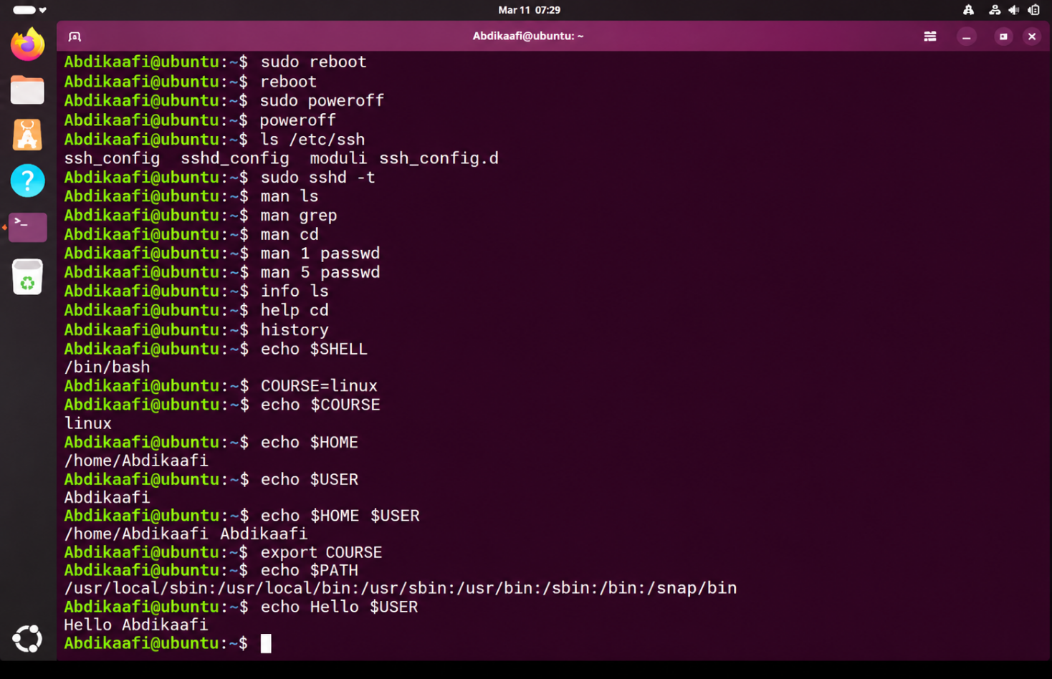
sudo reboot | reboot | Runs the command that follows with administrator privileges when permitted.  The command after sudo determines the action and may change system-wide settings.  Read the full command carefully and use elevated access only when it is necessary.
sudo poweroff | poweroff | Runs the command that follows with administrator privileges when permitted.  The command after sudo determines the action and may change system-wide settings.  Read the full command carefully and use elevated access only when it is necessary.
ls /etc/ssh | /etc/ssh | Lists files and directories in the selected location.  The path, filename, or option shown in the command determines what it acts on.  Check your location with pwd and verify the target before changing or deleting files.
sudo sshd -t | sshd -t | Runs the command that follows with administrator privileges when permitted.  The command after sudo determines the action and may change system-wide settings.  Read the full command carefully and use elevated access only when it is necessary.
man ls | ls | Displays help, prints text, or checks shell commands and environment settings.  It can help you learn command syntax, inspect variables, or review commands entered earlier.  Most forms display information or affect only the current shell session.
man grep | grep | Displays help, prints text, or checks shell commands and environment settings.  It can help you learn command syntax, inspect variables, or review commands entered earlier.  Most forms display information or affect only the current shell session.
man cd | cd | Displays help, prints text, or checks shell commands and environment settings.  It can help you learn command syntax, inspect variables, or review commands entered earlier.  Most forms display information or affect only the current shell session.
man 1 passwd | 1 passwd | Displays help, prints text, or checks shell commands and environment settings.  It can help you learn command syntax, inspect variables, or review commands entered earlier.  Most forms display information or affect only the current shell session.
man 5 passwd | 5 passwd | Displays help, prints text, or checks shell commands and environment settings.  It can help you learn command syntax, inspect variables, or review commands entered earlier.  Most forms display information or affect only the current shell session.
info ls | ls | Displays help, prints text, or checks shell commands and environment settings.  It can help you learn command syntax, inspect variables, or review commands entered earlier.  Most forms display information or affect only the current shell session.
help cd | cd | Displays help, prints text, or checks shell commands and environment settings.  It can help you learn command syntax, inspect variables, or review commands entered earlier.  Most forms display information or affect only the current shell session.
history | None | Displays help, prints text, or checks shell commands and environment settings.  It can help you learn command syntax, inspect variables, or review commands entered earlier.  Most forms display information or affect only the current shell session.
echo $SHELL | $SHELL | Displays help, prints text, or checks shell commands and environment settings.  It can help you learn command syntax, inspect variables, or review commands entered earlier.  Most forms display information or affect only the current shell session.
COURSE=linux | Variable assignment | Assigns the value linux to a shell variable named COURSE.  The value can be displayed with echo $COURSE in the current shell.  This assignment does not automatically export the variable to child processes.
echo $COURSE | $COURSE | Displays help, prints text, or checks shell commands and environment settings.  It can help you learn command syntax, inspect variables, or review commands entered earlier.  Most forms display information or affect only the current shell session.
echo $HOME | $HOME | Displays help, prints text, or checks shell commands and environment settings.  It can help you learn command syntax, inspect variables, or review commands entered earlier.  Most forms display information or affect only the current shell session.
echo $USER | $USER | Displays help, prints text, or checks shell commands and environment settings.  It can help you learn command syntax, inspect variables, or review commands entered earlier.  Most forms display information or affect only the current shell session.
echo $HOME $USER | $HOME $USER | Displays help, prints text, or checks shell commands and environment settings.  It can help you learn command syntax, inspect variables, or review commands entered earlier.  Most forms display information or affect only the current shell session.
export COURSE | COURSE | Displays help, prints text, or checks shell commands and environment settings.  It can help you learn command syntax, inspect variables, or review commands entered earlier.  Most forms display information or affect only the current shell session.
echo $PATH | $PATH | Displays help, prints text, or checks shell commands and environment settings.  It can help you learn command syntax, inspect variables, or review commands entered earlier.  Most forms display information or affect only the current shell session.
echo Hello $USER | Hello $USER | Displays help, prints text, or checks shell commands and environment settings.  It can help you learn command syntax, inspect variables, or review commands entered earlier.  Most forms display information or affect only the current shell session.
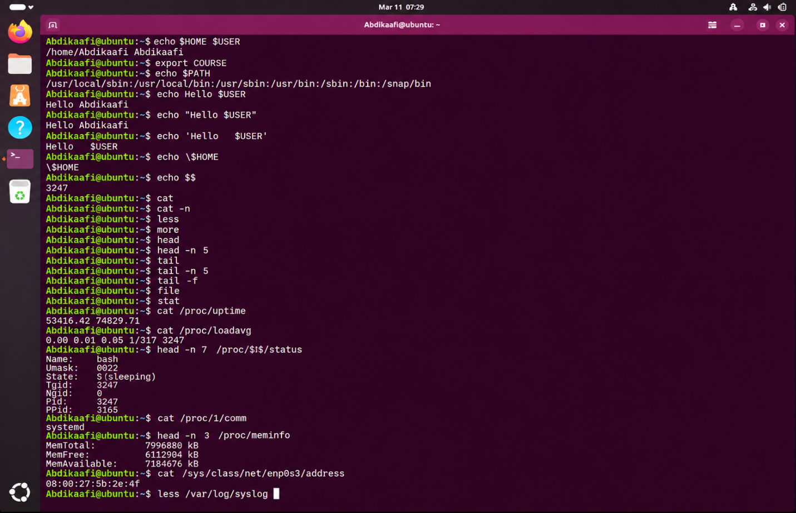
echo $HOME $USER | $HOME $USER | Displays help, prints text, or checks shell commands and environment settings.  It can help you learn command syntax, inspect variables, or review commands entered earlier.  Most forms display information or affect only the current shell session.
export COURSE | COURSE | Displays help, prints text, or checks shell commands and environment settings.  It can help you learn command syntax, inspect variables, or review commands entered earlier.  Most forms display information or affect only the current shell session.
echo $PATH | $PATH | Displays help, prints text, or checks shell commands and environment settings.  It can help you learn command syntax, inspect variables, or review commands entered earlier.  Most forms display information or affect only the current shell session.
echo Hello $USER | Hello $USER | Displays help, prints text, or checks shell commands and environment settings.  It can help you learn command syntax, inspect variables, or review commands entered earlier.  Most forms display information or affect only the current shell session.
echo "Hello $USER" | "Hello $USER" | Displays help, prints text, or checks shell commands and environment settings.  It can help you learn command syntax, inspect variables, or review commands entered earlier.  Most forms display information or affect only the current shell session.
echo 'Hello $USER' | 'Hello $USER' | Displays help, prints text, or checks shell commands and environment settings.  It can help you learn command syntax, inspect variables, or review commands entered earlier.  Most forms display information or affect only the current shell session.
echo \$HOME | \$HOME | Displays help, prints text, or checks shell commands and environment settings.  It can help you learn command syntax, inspect variables, or review commands entered earlier.  Most forms display information or affect only the current shell session.
echo $$ | $$ | Displays help, prints text, or checks shell commands and environment settings.  It can help you learn command syntax, inspect variables, or review commands entered earlier.  Most forms display information or affect only the current shell session.
cat | None | Displays file contents or information about a file.  Options can limit output, follow new log entries, or show additional file details.  These commands are useful when reading text files, configuration files, and system logs.
cat -n | -n | Displays file contents or information about a file.  Options can limit output, follow new log entries, or show additional file details.  These commands are useful when reading text files, configuration files, and system logs.
less | None | Displays file contents or information about a file.  Options can limit output, follow new log entries, or show additional file details.  These commands are useful when reading text files, configuration files, and system logs.
more | None | Displays file contents or information about a file.  Options can limit output, follow new log entries, or show additional file details.  These commands are useful when reading text files, configuration files, and system logs.
head | None | Displays file contents or information about a file.  Options can limit output, follow new log entries, or show additional file details.  These commands are useful when reading text files, configuration files, and system logs.
head -n | -n | Displays file contents or information about a file.  Options can limit output, follow new log entries, or show additional file details.  These commands are useful when reading text files, configuration files, and system logs.
tail | None | Displays file contents or information about a file.  Options can limit output, follow new log entries, or show additional file details.  These commands are useful when reading text files, configuration files, and system logs.
tail -n | -n | Displays file contents or information about a file.  Options can limit output, follow new log entries, or show additional file details.  These commands are useful when reading text files, configuration files, and system logs.
tail -f | -f | Displays file contents or information about a file.  Options can limit output, follow new log entries, or show additional file details.  These commands are useful when reading text files, configuration files, and system logs.
file | None | Displays file contents or information about a file.  Options can limit output, follow new log entries, or show additional file details.  These commands are useful when reading text files, configuration files, and system logs.
stat | None | Displays file contents or information about a file.  Options can limit output, follow new log entries, or show additional file details.  These commands are useful when reading text files, configuration files, and system logs.
cat /proc/uptime | /proc/uptime | Displays file contents or information about a file.  Options can limit output, follow new log entries, or show additional file details.  These commands are useful when reading text files, configuration files, and system logs.
cat /proc/loadavg | /proc/loadavg | Displays file contents or information about a file.  Options can limit output, follow new log entries, or show additional file details.  These commands are useful when reading text files, configuration files, and system logs.
head -n 7 /proc/$$/status | -n 7 /proc/$$/status | Displays file contents or information about a file.  Options can limit output, follow new log entries, or show additional file details.  These commands are useful when reading text files, configuration files, and system logs.
cat /proc/1/comm | /proc/1/comm | Displays file contents or information about a file.  Options can limit output, follow new log entries, or show additional file details.  These commands are useful when reading text files, configuration files, and system logs.
head -n 3 /proc/meminfo | -n 3 /proc/meminfo | Displays file contents or information about a file.  Options can limit output, follow new log entries, or show additional file details.  These commands are useful when reading text files, configuration files, and system logs.
cat /sys/class/net/enp0s3/address | /sys/class/net/enp0s3/address | Displays file contents or information about a file.  Options can limit output, follow new log entries, or show additional file details.  These commands are useful when reading text files, configuration files, and system logs.
less /var/log/syslog | /var/log/syslog | Displays file contents or information about a file.  Options can limit output, follow new log entries, or show additional file details.  These commands are useful when reading text files, configuration files, and system logs.
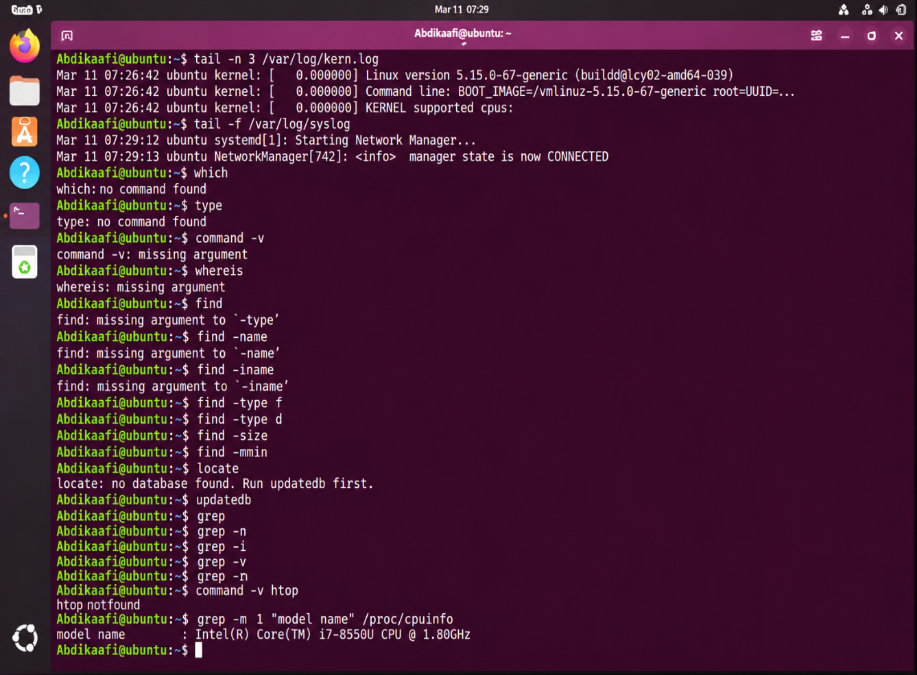
tail -n 3 /var/log/kern.log | -n 3 /var/log/kern.log 9 | Displays file contents or information about a file.  Options can limit output, follow new log entries, or show additional file details.  These commands are useful when reading text files, configuration files, and system logs.
tail -f /var/log/syslog | -f /var/log/syslog | Displays file contents or information about a file.  Options can limit output, follow new log entries, or show additional file details.  These commands are useful when reading text files, configuration files, and system logs.
which | None | Displays help, prints text, or checks shell commands and environment settings.  It can help you learn command syntax, inspect variables, or review commands entered earlier.  Most forms display information or affect only the current shell session.
type | None | Displays help, prints text, or checks shell commands and environment settings.  It can help you learn command syntax, inspect variables, or review commands entered earlier.  Most forms display information or affect only the current shell session.
command -v | -v | Displays help, prints text, or checks shell commands and environment settings.  It can help you learn command syntax, inspect variables, or review commands entered earlier.  Most forms display information or affect only the current shell session.
whereis | None | Displays help, prints text, or checks shell commands and environment settings.  It can help you learn command syntax, inspect variables, or review commands entered earlier.  Most forms display information or affect only the current shell session.
find | None | Searches for files or text that match a name, pattern, or condition.  Options can refine the search by case, file type, location, or matching line number.  Use a clear search path and specific pattern to avoid receiving too many results.
find -name | -name | Searches for files or text that match a name, pattern, or condition.  Options can refine the search by case, file type, location, or matching line number.  Use a clear search path and specific pattern to avoid receiving too many results.
find -iname | -iname | Searches for files or text that match a name, pattern, or condition.  Options can refine the search by case, file type, location, or matching line number.  Use a clear search path and specific pattern to avoid receiving too many results.
find -type f | -type f | Searches for files or text that match a name, pattern, or condition.  Options can refine the search by case, file type, location, or matching line number.  Use a clear search path and specific pattern to avoid receiving too many results.
find -type d | -type d | Searches for files or text that match a name, pattern, or condition.  Options can refine the search by case, file type, location, or matching line number.  Use a clear search path and specific pattern to avoid receiving too many results.
find -size | -size | Searches for files or text that match a name, pattern, or condition.  Options can refine the search by case, file type, location, or matching line number.  Use a clear search path and specific pattern to avoid receiving too many results.
find -mmin | -mmin | Searches for files or text that match a name, pattern, or condition.  Options can refine the search by case, file type, location, or matching line number.  Use a clear search path and specific pattern to avoid receiving too many results.
locate | None | Searches for files or text that match a name, pattern, or condition.  Options can refine the search by case, file type, location, or matching line number.  Use a clear search path and specific pattern to avoid receiving too many results.
updatedb | None | Searches for files or text that match a name, pattern, or condition.  Options can refine the search by case, file type, location, or matching line number.  Use a clear search path and specific pattern to avoid receiving too many results.
grep | None | Searches for files or text that match a name, pattern, or condition.  Options can refine the search by case, file type, location, or matching line number.  Use a clear search path and specific pattern to avoid receiving too many results.
grep -n | -n | Searches for files or text that match a name, pattern, or condition.  Options can refine the search by case, file type, location, or matching line number.  Use a clear search path and specific pattern to avoid receiving too many results.
grep -i | -i | Searches for files or text that match a name, pattern, or condition.  Options can refine the search by case, file type, location, or matching line number.  Use a clear search path and specific pattern to avoid receiving too many results.
grep -v | -v | Searches for files or text that match a name, pattern, or condition.  Options can refine the search by case, file type, location, or matching line number.  Use a clear search path and specific pattern to avoid receiving too many results.
grep -r | -r | Searches for files or text that match a name, pattern, or condition.  Options can refine the search by case, file type, location, or matching line number.  Use a clear search path and specific pattern to avoid receiving too many results.
grep -rn | -rn | Searches for files or text that match a name, pattern, or condition.  Options can refine the search by case, file type, location, or matching line number.  Use a clear search path and specific pattern to avoid receiving too many results.
command -v htop | -v htop | Displays help, prints text, or checks shell commands and environment settings.  It can help you learn command syntax, inspect variables, or review commands entered earlier.  Most forms display information or affect only the current shell session.
grep -m 1 "model name" /proc/cpuinfo | -m 1 "model name" /proc/cpuinfo | Searches for files or text that match a name, pattern, or condition.  Options can refine the search by case, file type, location, or matching line number.  Use a clear search path and specific pattern to avoid receiving too many results.
grep -c ^processor /proc/cpuinfo | -c ^processor /proc/cpuinfo | Searches for files or text that match a name, pattern, or condition.  Options can refine the search by case, file type, location, or matching line number.  Use a clear search path and specific pattern to avoid receiving too many results.
grep sudo /var/log/auth.log | tail -n 1 | sudo /var/log/auth.log | tail -n 1 | Searches for files or text that match a name, pattern, or condition.  Options can refine the search by case, file type, location, or matching line number.  Use a clear search path and specific pattern to avoid receiving too many results.
> | Shell operator / special parameter | This is a shell operator or special parameter rather than a standalone Linux program.  It redirects input or output, connects commands, controls command order, or reports an exit status.  Its meaning depends on its position in a complete shell command.
>> | Shell operator / special parameter | This is a shell operator or special parameter rather than a standalone Linux program.  It redirects input or output, connects commands, controls command order, or reports an exit status.  Its meaning depends on its position in a complete shell command.
2> | Shell operator / special parameter | This is a shell operator or special parameter rather than a standalone Linux program.  It redirects input or output, connects commands, controls command order, or reports an exit status.  Its meaning depends on its position in a complete shell command.
< | Shell operator / special parameter | This is a shell operator or special parameter rather than a standalone Linux program.  It redirects input or output, connects commands, controls command order, or reports an exit status.  Its meaning depends on its position in a complete shell command.
| | Shell operator / special parameter | This is a shell operator or special parameter rather than a standalone Linux program.  It redirects input or output, connects commands, controls command order, or reports an exit status.  Its meaning depends on its position in a complete shell command.
; | Shell operator / special parameter | This is a shell operator or special parameter rather than a standalone Linux program.  It redirects input or output, connects commands, controls command order, or reports an exit status.  Its meaning depends on its position in a complete shell command.
&& | Shell operator / special parameter | This is a shell operator or special parameter rather than a standalone Linux program.  It redirects input or output, connects commands, controls command order, or reports an exit status.  Its meaning depends on its position in a complete shell command.
|| | Shell operator / special parameter | This is a shell operator or special parameter rather than a standalone Linux program.  It redirects input or output, connects commands, controls command order, or reports an exit status.  Its meaning depends on its position in a complete shell command.
$? | Shell operator / special parameter | This is a shell operator or special parameter rather than a standalone Linux program.  It redirects input or output, connects commands, controls command order, or reports an exit status.  Its meaning depends on its position in a complete shell command.

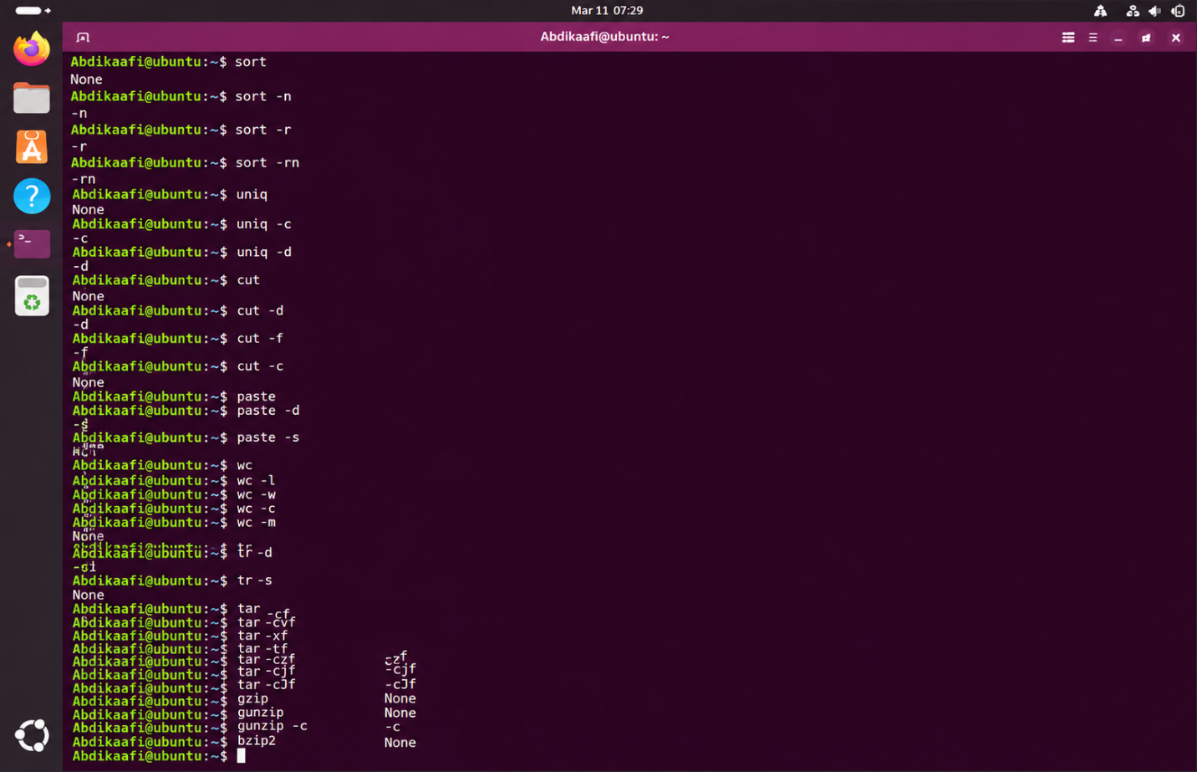

sort | None | Processes text from a file or standard input and writes the result to standard output.  Options select sorting order, fields, characters, counts, or character transformations.  These tools are often combined with pipes to create useful command-line workflows.
sort -n | -n | Processes text from a file or standard input and writes the result to standard output.  Options select sorting order, fields, characters, counts, or character transformations.  These tools are often combined with pipes to create useful command-line workflows.
sort -r | -r | Processes text from a file or standard input and writes the result to standard output.  Options select sorting order, fields, characters, counts, or character transformations.  These tools are often combined with pipes to create useful command-line workflows.
sort -rn | -rn | Processes text from a file or standard input and writes the result to standard output.  Options select sorting order, fields, characters, counts, or character transformations.  These tools are often combined with pipes to create useful command-line workflows.
uniq | None | Processes text from a file or standard input and writes the result to standard output.  Options select sorting order, fields, characters, counts, or character transformations.  These tools are often combined with pipes to create useful command-line workflows.
uniq -c | -c | Processes text from a file or standard input and writes the result to standard output.  Options select sorting order, fields, characters, counts, or character transformations.  These tools are often combined with pipes to create useful command-line workflows.
uniq -d | -d | Processes text from a file or standard input and writes the result to standard output.  Options select sorting order, fields, characters, counts, or character transformations.  These tools are often combined with pipes to create useful command-line workflows.
cut | None | Processes text from a file or standard input and writes the result to standard output.  Options select sorting order, fields, characters, counts, or character transformations.  These tools are often combined with pipes to create useful command-line workflows.
cut -d | -d | Processes text from a file or standard input and writes the result to standard output.  Options select sorting order, fields, characters, counts, or character transformations.  These tools are often combined with pipes to create useful command-line workflows.
cut -f | -f | Processes text from a file or standard input and writes the result to standard output.  Options select sorting order, fields, characters, counts, or character transformations.  These tools are often combined with pipes to create useful command-line workflows.
cut -c | -c | Processes text from a file or standard input and writes the result to standard output.  Options select sorting order, fields, characters, counts, or character transformations.  These tools are often combined with pipes to create useful command-line workflows.
paste | None | Processes text from a file or standard input and writes the result to standard output.  Options select sorting order, fields, characters, counts, or character transformations.  These tools are often combined with pipes to create useful command-line workflows.
paste -d | -d | Processes text from a file or standard input and writes the result to standard output.  Options select sorting order, fields, characters, counts, or character transformations.  These tools are often combined with pipes to create useful command-line workflows.
paste -s | -s | Processes text from a file or standard input and writes the result to standard output.  Options select sorting order, fields, characters, counts, or character transformations.  These tools are often combined with pipes to create useful command-line workflows.
wc | None | Processes text from a file or standard input and writes the result to standard output.  Options select sorting order, fields, characters, counts, or character transformations.  These tools are often combined with pipes to create useful command-line workflows.
wc -l | -l | Processes text from a file or standard input and writes the result to standard output.  Options select sorting order, fields, characters, counts, or character transformations.  These tools are often combined with pipes to create useful command-line workflows.
wc -w | -w | Processes text from a file or standard input and writes the result to standard output.  Options select sorting order, fields, characters, counts, or character transformations.  These tools are often combined with pipes to create useful command-line workflows.
wc -c | -c | Processes text from a file or standard input and writes the result to standard output.  Options select sorting order, fields, characters, counts, or character transformations.  These tools are often combined with pipes to create useful command-line workflows.
wc -m | -m | Processes text from a file or standard input and writes the result to standard output.  Options select sorting order, fields, characters, counts, or character transformations.  These tools are often combined with pipes to create useful command-line workflows.
tr | None | Processes text from a file or standard input and writes the result to standard output.  Options select sorting order, fields, characters, counts, or character transformations.  These tools are often combined with pipes to create useful command-line workflows.
tr -d | -d | Processes text from a file or standard input and writes the result to standard output.  Options select sorting order, fields, characters, counts, or character transformations.  These tools are often combined with pipes to create useful command-line workflows.
tr -s | -s | Processes text from a file or standard input and writes the result to standard output.  Options select sorting order, fields, characters, counts, or character transformations.  These tools are often combined with pipes to create useful command-line workflows.
tar | None | Creates, lists, extracts, or compresses archive files and data.  The options determine the archive format and whether files are added, listed, or extracted.  Check the archive name and destination before extracting files.
tar -cf | -cf | Creates, lists, extracts, or compresses archive files and data.  The options determine the archive format and whether files are added, listed, or extracted.  Check the archive name and destination before extracting files.
tar -cvf | -cvf | Creates, lists, extracts, or compresses archive files and data.  The options determine the archive format and whether files are added, listed, or extracted.  Check the archive name and destination before extracting files.
tar -xf | -xf | Creates, lists, extracts, or compresses archive files and data.  The options determine the archive format and whether files are added, listed, or extracted.  Check the archive name and destination before extracting files.
tar -tf | -tf | Creates, lists, extracts, or compresses archive files and data.  The options determine the archive format and whether files are added, listed, or extracted.  Check the archive name and destination before extracting files.
tar -czf | -czf | Creates, lists, extracts, or compresses archive files and data.  The options determine the archive format and whether files are added, listed, or extracted.  Check the archive name and destination before extracting files.
tar -cjf | -cjf | Creates, lists, extracts, or compresses archive files and data.  The options determine the archive format and whether files are added, listed, or extracted.  Check the archive name and destination before extracting files.
tar -cJf | -cJf | Creates, lists, extracts, or compresses archive files and data.  The options determine the archive format and whether files are added, listed, or extracted.  Check the archive name and destination before extracting files.
gzip | None | Creates, lists, extracts, or compresses archive files and data.  The options determine the archive format and whether files are added, listed, or extracted.  Check the archive name and destination before extracting files.
gunzip | None | Creates, lists, extracts, or compresses archive files and data.  The options determine the archive format and whether files are added, listed, or extracted.  Check the archive name and destination before extracting files.
gunzip -c | -c | Creates, lists, extracts, or compresses archive files and data.  The options determine the archive format and whether files are added, listed, or extracted.  Check the archive name and destination before extracting files.
bzip2 | None | Creates, lists, extracts, or compresses archive files and data.  The options determine the archive format and whether files are added, listed, or extracted.  Check the archive name and destination before extracting files.

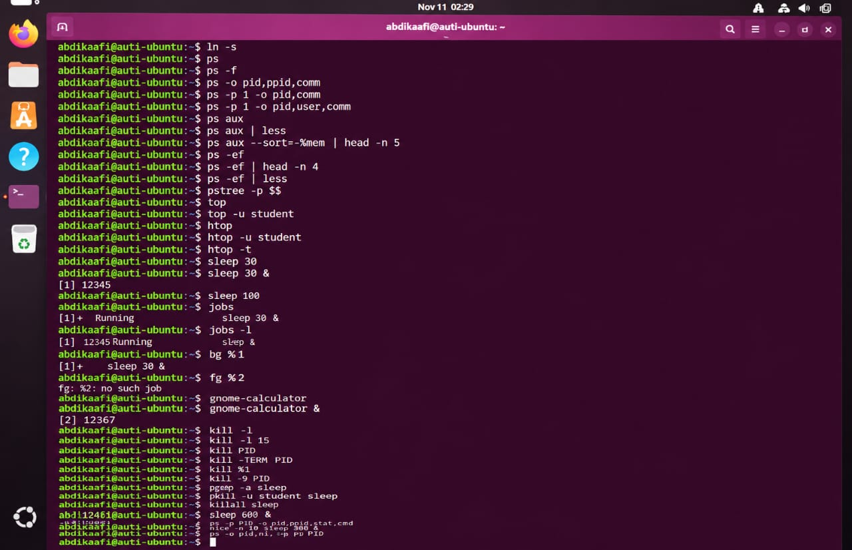

bunzip2 | None | Creates, lists, extracts, or compresses archive files and data.  The options determine the archive format and whether files are added, listed, or extracted.  Check the archive name and destination before extracting files.
bzcat | None | Creates, lists, extracts, or compresses archive files and data.  The options determine the archive format and whether files are added, listed, or extracted.  Check the archive name and destination before extracting files.
xz | None | Creates, lists, extracts, or compresses archive files and data.  The options determine the archive format and whether files are added, listed, or extracted.  Check the archive name and destination before extracting files.
unxz | None | Creates, lists, extracts, or compresses archive files and data.  The options determine the archive format and whether files are added, listed, or extracted.  Check the archive name and destination before extracting files.
xzcat | None | Creates, lists, extracts, or compresses archive files and data.  The options determine the archive format and whether files are added, listed, or extracted.  Check the archive name and destination before extracting files.
zip | None | Creates, lists, extracts, or compresses archive files and data.  The options determine the archive format and whether files are added, listed, or extracted.  Check the archive name and destination before extracting files.
zip -r | -r | Creates, lists, extracts, or compresses archive files and data.  The options determine the archive format and whether files are added, listed, or extracted.  Check the archive name and destination before extracting files.
unzip | None | Creates, lists, extracts, or compresses archive files and data.  The options determine the archive format and whether files are added, listed, or extracted.  Check the archive name and destination before extracting files.
unzip -l | -l | Creates, lists, extracts, or compresses archive files and data.  The options determine the archive format and whether files are added, listed, or extracted.  Check the archive name and destination before extracting files.
unzip -d | -d | Creates, lists, extracts, or compresses archive files and data.  The options determine the archive format and whether files are added, listed, or extracted.  Check the archive name and destination before extracting files.
nano | None | Opens or controls a terminal-based text editor.  The command, key, or mode shown performs an editing, saving, searching, or exiting action.  Shortcuts can differ by editor and mode, so check the editor's help when needed.
vim | None | Opens or controls a terminal-based text editor.  The command, key, or mode shown performs an editing, saving, searching, or exiting action.  Shortcuts can differ by editor and mode, so check the editor's help when needed.
vi | None | Opens or controls a terminal-based text editor.  The command, key, or mode shown performs an editing, saving, searching, or exiting action.  Shortcuts can differ by editor and mode, so check the editor's help when needed.
vimtutor | None | Opens or controls a terminal-based text editor.  The command, key, or mode shown performs an editing, saving, searching, or exiting action.  Shortcuts can differ by editor and mode, so check the editor's help when needed.
Ctrl + O | Editor shortcut or mode command | Opens or controls a terminal-based text editor.  The command, key, or mode shown performs an editing, saving, searching, or exiting action.  Shortcuts can differ by editor and mode, so check the editor's help when needed.
Ctrl + X | Editor shortcut or mode command | Opens or controls a terminal-based text editor.  The command, key, or mode shown performs an editing, saving, searching, or exiting action.  Shortcuts can differ by editor and mode, so check the editor's help when needed.
Ctrl + W | Editor shortcut or mode command | Opens or controls a terminal-based text editor.  The command, key, or mode shown performs an editing, saving, searching, or exiting action.  Shortcuts can differ by editor and mode, so check the editor's help when needed.
Ctrl + K | Editor shortcut or mode command | Opens or controls a terminal-based text editor.  The command, key, or mode shown performs an editing, saving, searching, or exiting action.  Shortcuts can differ by editor and mode, so check the editor's help when needed.
Ctrl + U | Editor shortcut or mode command | Opens or controls a terminal-based text editor.  The command, key, or mode shown performs an editing, saving, searching, or exiting action.  Shortcuts can differ by editor and mode, so check the editor's help when needed.
Alt + U | Editor shortcut or mode command | Opens or controls a terminal-based text editor.  The command, key, or mode shown performs an editing, saving, searching, or exiting action.  Shortcuts can differ by editor and mode, so check the editor's help when needed.
i | Editor shortcut or mode command | Opens or controls a terminal-based text editor.  The command, key, or mode shown performs an editing, saving, searching, or exiting action.  Shortcuts can differ by editor and mode, so check the editor's help when needed.
Esc | Editor shortcut or mode command | Opens or controls a terminal-based text editor.  The command, key, or mode shown performs an editing, saving, searching, or exiting action.  Shortcuts can differ by editor and mode, so check the editor's help when needed.
:w | Editor shortcut or mode command | Opens or controls a terminal-based text editor.  The command, key, or mode shown performs an editing, saving, searching, or exiting action.  Shortcuts can differ by editor and mode, so check the editor's help when needed.
:q | Editor shortcut or mode command | Opens or controls a terminal-based text editor.  The command, key, or mode shown performs an editing, saving, searching, or exiting action.  Shortcuts can differ by editor and mode, so check the editor's help when needed.
:wq | Editor shortcut or mode command | Opens or controls a terminal-based text editor.  The command, key, or mode shown performs an editing, saving, searching, or exiting action.  Shortcuts can differ by editor and mode, so check the editor's help when needed.
:q! | Editor shortcut or mode command | Opens or controls a terminal-based text editor.  The command, key, or mode shown performs an editing, saving, searching, or exiting action.  Shortcuts can differ by editor and mode, so check the editor's help when needed.
ln | None | Creates a link that points to an existing file or directory.  A symbolic link stores a path, while a hard link refers to the same file data.  Use ls -l to inspect symbolic links and ls -li to compare inode numbers.
ln -s | -s | Creates a link that points to an existing file or directory.  A symbolic link stores a path, while a hard link refers to the same file data.  Use ls -l to inspect symbolic links and ls -li to compare inode numbers.
ps | None | Inspects or manages running processes and shell jobs.  Options can filter processes, display selected details, change priority, or send a signal.  Use the correct process ID or job number and manage only processes you are allowed to control.
ps -f | -f | Inspects or manages running processes and shell jobs.  Options can filter processes, display selected details, change priority, or send a signal.  Use the correct process ID or job number and manage only processes you are allowed to control.
ps -o pid,ppid,comm | -o pid,ppid,comm | Inspects or manages running processes and shell jobs.  Options can filter processes, display selected details, change priority, or send a signal.  Use the correct process ID or job number and manage only processes you are allowed to control.
ps -p 1 -o pid,comm | -p 1 -o pid,comm | Inspects or manages running processes and shell jobs.  Options can filter processes, display selected details, change priority, or send a signal.  Use the correct process ID or job number and manage only processes you are allowed to control.
ps -p 1 -o pid,user,comm | -p 1 -o pid,user,comm | Inspects or manages running processes and shell jobs.  Options can filter processes, display selected details, change priority, or send a signal.  Use the correct process ID or job number and manage only processes you are allowed to control.
ps aux | aux | Inspects or manages running processes and shell jobs.  Options can filter processes, display selected details, change priority, or send a signal.  Use the correct process ID or job number and manage only processes you are allowed to control.
ps aux | less | aux | less | Inspects or manages running processes and shell jobs.  Options can filter processes, display selected details, change priority, or send a signal.  Use the correct process ID or job number and manage only processes you are allowed to control.
ps aux --sort=-%mem | head -n 5 | Variable assignment | Inspects or manages running processes and shell jobs.  Options can filter processes, display selected details, change priority, or send a signal.  Use the correct process ID or job number and manage only processes you are allowed to control.
ps -ef | -ef | Inspects or manages running processes and shell jobs.  Options can filter processes, display selected details, change priority, or send a signal.  Use the correct process ID or job number and manage only processes you are allowed to control.
ps -ef | head -n 4 | -ef | head -n 4 | Inspects or manages running processes and shell jobs.  Options can filter processes, display selected details, change priority, or send a signal.  Use the correct process ID or job number and manage only processes you are allowed to control.
ps -ef | less | -ef | less | Inspects or manages running processes and shell jobs.  Options can filter processes, display selected details, change priority, or send a signal.  Use the correct process ID or job number and manage only processes you are allowed to control.
pstree -p $$ | -p $$ | Inspects or manages running processes and shell jobs.  Options can filter processes, display selected details, change priority, or send a signal.  Use the correct process ID or job number and manage only processes you are allowed to control.
top | None | Inspects or manages running processes and shell jobs.  Options can filter processes, display selected details, change priority, or send a signal.  Use the correct process ID or job number and manage only processes you are allowed to control.
top -u student | -u student | Inspects or manages running processes and shell jobs.  Options can filter processes, display selected details, change priority, or send a signal.  Use the correct process ID or job number and manage only processes you are allowed to control.
htop | None | Inspects or manages running processes and shell jobs.  Options can filter processes, display selected details, change priority, or send a signal.  Use the correct process ID or job number and manage only processes you are allowed to control.
htop -u student | -u student | Inspects or manages running processes and shell jobs.  Options can filter processes, display selected details, change priority, or send a signal.  Use the correct process ID or job number and manage only processes you are allowed to control.
htop -t | -t | Inspects or manages running processes and shell jobs.  Options can filter processes, display selected details, change priority, or send a signal.  Use the correct process ID or job number and manage only processes you are allowed to control.
sleep 30 | 30 | Inspects or manages running processes and shell jobs.  Options can filter processes, display selected details, change priority, or send a signal.  Use the correct process ID or job number and manage only processes you are allowed to control.
sleep 30 & | 30 & | Inspects or manages running processes and shell jobs.  Options can filter processes, display selected details, change priority, or send a signal.  Use the correct process ID or job number and manage only processes you are allowed to control.
sleep 100 | 100 | Inspects or manages running processes and shell jobs.  Options can filter processes, display selected details, change priority, or send a signal.  Use the correct process ID or job number and manage only processes you are allowed to control.
jobs | None | Inspects or manages running processes and shell jobs.  Options can filter processes, display selected details, change priority, or send a signal.  Use the correct process ID or job number and manage only processes you are allowed to control.
jobs -l | -l | Inspects or manages running processes and shell jobs.  Options can filter processes, display selected details, change priority, or send a signal.  Use the correct process ID or job number and manage only processes you are allowed to control.
bg %1 | %1 | Inspects or manages running processes and shell jobs.  Options can filter processes, display selected details, change priority, or send a signal.  Use the correct process ID or job number and manage only processes you are allowed to control.
fg %2 | %2 | Inspects or manages running processes and shell jobs.  Options can filter processes, display selected details, change priority, or send a signal.  Use the correct process ID or job number and manage only processes you are allowed to control.
fg | None | Inspects or manages running processes and shell jobs.  Options can filter processes, display selected details, change priority, or send a signal.  Use the correct process ID or job number and manage only processes you are allowed to control.
gnome-calculator | None | Inspects or manages running processes and shell jobs.  Options can filter processes, display selected details, change priority, or send a signal.  Use the correct process ID or job number and manage only processes you are allowed to control.
gnome-calculator & | & | Inspects or manages running processes and shell jobs.  Options can filter processes, display selected details, change priority, or send a signal.  Use the correct process ID or job number and manage only processes you are allowed to control.
kill -l | -l | Inspects or manages running processes and shell jobs.  Options can filter processes, display selected details, change priority, or send a signal.  Use the correct process ID or job number and manage only processes you are allowed to control.
kill -l 15 | -l 15 | Inspects or manages running processes and shell jobs.  Options can filter processes, display selected details, change priority, or send a signal.  Use the correct process ID or job number and manage only processes you are allowed to control.
kill PID | PID | Inspects or manages running processes and shell jobs.  Options can filter processes, display selected details, change priority, or send a signal.  Use the correct process ID or job number and manage only processes you are allowed to control.
kill -TERM PID | -TERM PID | Inspects or manages running processes and shell jobs.  Options can filter processes, display selected details, change priority, or send a signal.  Use the correct process ID or job number and manage only processes you are allowed to control.
kill %1 | %1 | Inspects or manages running processes and shell jobs.  Options can filter processes, display selected details, change priority, or send a signal.  Use the correct process ID or job number and manage only processes you are allowed to control.
kill -9 PID | -9 PID | Inspects or manages running processes and shell jobs.  Options can filter processes, display selected details, change priority, or send a signal.  Use the correct process ID or job number and manage only processes you are allowed to control.
pgrep -a sleep | -a sleep | Inspects or manages running processes and shell jobs.  Options can filter processes, display selected details, change priority, or send a signal.  Use the correct process ID or job number and manage only processes you are allowed to control.
pkill -u student sleep | -u student sleep | Inspects or manages running processes and shell jobs.  Options can filter processes, display selected details, change priority, or send a signal.  Use the correct process ID or job number and manage only processes you are allowed to control.
killall sleep | sleep | Inspects or manages running processes and shell jobs.  Options can filter processes, display selected details, change priority, or send a signal.  Use the correct process ID or job number and manage only processes you are allowed to control.
sleep 600 & | 600 & | Inspects or manages running processes and shell jobs.  Options can filter processes, display selected details, change priority, or send a signal.  Use the correct process ID or job number and manage only processes you are allowed to control.
ps -p PID | -p PID | Inspects or manages running processes and shell jobs.  Options can filter processes, display selected details, change priority, or send a signal.  Use the correct process ID or job number and manage only processes you are allowed to control.
ps -p PID -o pid,ppid,stat,cmd | -p PID -o pid,ppid,stat,cmd | Inspects or manages running processes and shell jobs.  Options can filter processes, display selected details, change priority, or send a signal.  Use the correct process ID or job number and manage only processes you are allowed to control.

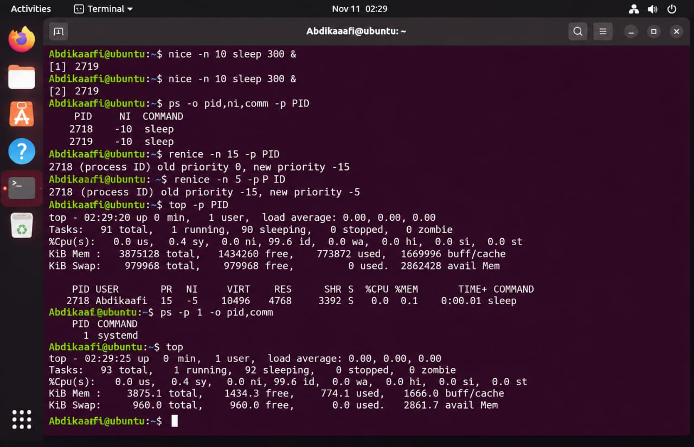

nice -n 10 sleep 300 & | -n 10 sleep 300 & | Inspects or manages running processes and shell jobs.  Options can filter processes, display selected details, change priority, or send a signal.  Use the correct process ID or job number and manage only processes you are allowed to control.
ps -o pid,ni,comm -p PID | -o pid,ni,comm -p PID | Inspects or manages running processes and shell jobs.  Options can filter processes, display selected details, change priority, or send a signal.  Use the correct process ID or job number and manage only processes you are allowed to control.
renice -n 15 -p PID | -n 15 -p PID | Inspects or manages running processes and shell jobs.  Options can filter processes, display selected details, change priority, or send a signal.  Use the correct process ID or job number and manage only processes you are allowed to control.
renice -n 5 -p PID 2ooo | -n 5 -p PID | Inspects or manages running processes and shell jobs.  Options can filter processes, display selected details, change priority, or send a signal.  Use the correct process ID or job number and manage only processes you are allowed to control.
top -p PID | -p PID | Inspects or manages running processes and shell jobs.  Options can filter processes, display selected details, change priority, or send a signal.  Use the correct process ID or job number and manage only processes you are allowed to control.
ps -p 1 -o pid,comm | -p 1 -o pid,comm | Inspects or manages running processes and shell jobs.  Options can filter processes, display selected details, change priority, or send a signal.  Use the correct process ID or job number and manage only processes you are allowed to control.
top | None | Inspects or manages running processes and shell jobs.  Options can filter processes, display selected details, change priority, or send a signal.  Use the correct process ID or job number and manage only processes you are allowed to control.
systemctl cat cron | cat cron | Inspects Linux services, system logs, or kernel messages.  Options can select a service, time range, severity level, or number of log entries.  Commands that use sudo or change service state should be run only when you understand their effect.
systemctl status cron | status cron | Inspects Linux services, system logs, or kernel messages.  Options can select a service, time range, severity level, or number of log entries.  Commands that use sudo or change service state should be run only when you understand their effect.
systemctl is-active cron | is-active cron | Inspects Linux services, system logs, or kernel messages.  Options can select a service, time range, severity level, or number of log entries.  Commands that use sudo or change service state should be run only when you understand their effect.
systemctl is-enabled cron | is-enabled cron | Inspects Linux services, system logs, or kernel messages.  Options can select a service, time range, severity level, or number of log entries.  Commands that use sudo or change service state should be run only when you understand their effect.
systemctl show -p MainPID cron | show -p MainPID cron | Inspects Linux services, system logs, or kernel messages.  Options can select a service, time range, severity level, or number of log entries.  Commands that use sudo or change service state should be run only when you understand their effect.
systemctl list-units --type=service --state=running | Variable assignment | Inspects Linux services, system logs, or kernel messages.  Options can select a service, time range, severity level, or number of log entries.  Commands that use sudo or change service state should be run only when you understand their effect.
systemctl list-units --type=service --state=failed | Variable assignment | Inspects Linux services, system logs, or kernel messages.  Options can select a service, time range, severity level, or number of log entries.  Commands that use sudo or change service state should be run only when you understand their effect.
journalctl -n 3 | -n 3 | Inspects Linux services, system logs, or kernel messages.  Options can select a service, time range, severity level, or number of log entries.  Commands that use sudo or change service state should be run only when you understand their effect.
journalctl -b | -b | Inspects Linux services, system logs, or kernel messages.  Options can select a service, time range, severity level, or number of log entries.  Commands that use sudo or change service state should be run only when you understand their effect.
journalctl -b -p err | -b -p err | Inspects Linux services, system logs, or kernel messages.  Options can select a service, time range, severity level, or number of log entries.  Commands that use sudo or change service state should be run only when you understand their effect.
journalctl -u cron -n 4 | -u cron -n 4 | Inspects Linux services, system logs, or kernel messages.  Options can select a service, time range, severity level, or number of log entries.  Commands that use sudo or change service state should be run only when you understand their effect.

